


Knowledge and skills for social work with adults
Assessment Tool for ASYE

Date:

Newly Qualified Social Worker
Name: Signature:

Line Manager
Name: Signature:


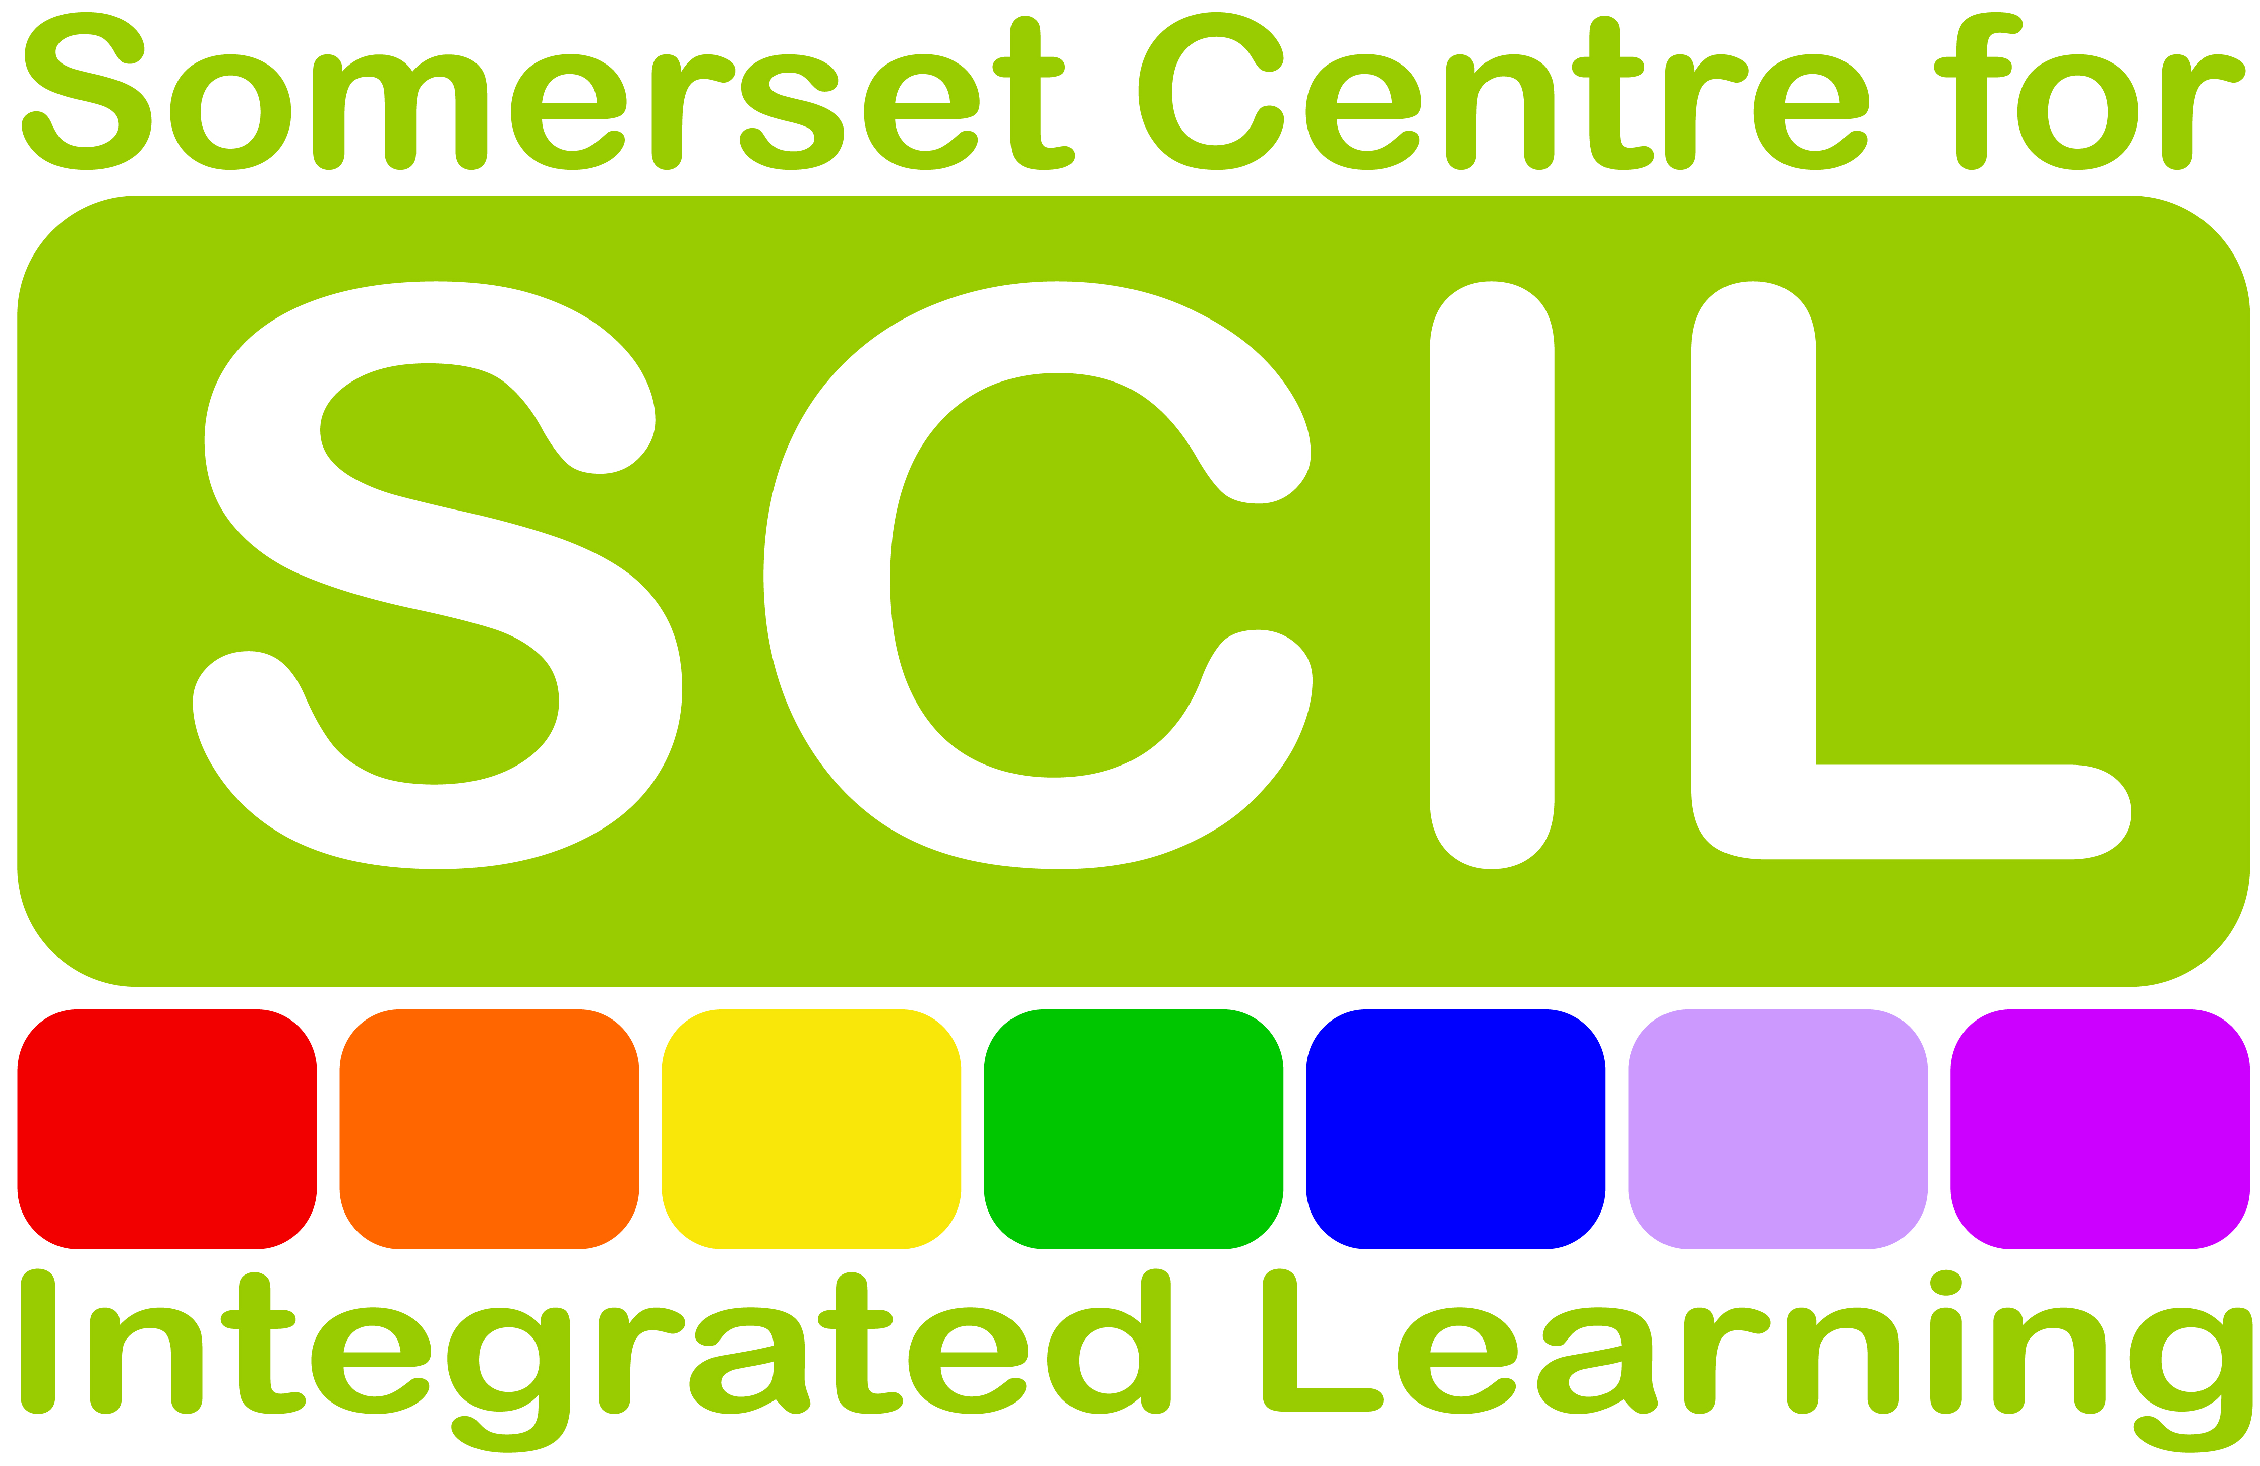
SCIL@somerset.gov.uk01823 368280www.scilearning.org.uk

In March 2015, following public consultations, the government published the Knowledge and Skills Statement to define specifically what we should expect a social worker with adults to know and be able to do after their first year in employment. The statement was written with advice from the Chief Social Worker for Adults, Lyn Romeo.
Background

Instructions

It is important to spend time with your line manager reflecting on your practice and assessing against each statement. You should add in references to WRITTEN evidence that will support your rating, e.g. supervision notes, case records, assessments, reports, letters and emails.
Under each statement, rate yourself from 1 to 3 on how well you believe you meet that particular statement for children’s social work in your workplace.

1: This is an area I need to develop
2: I am making progress towards this statement
3. I am able to demonstrate knowledge & skill at ASYE level

What’s next?

Consider your areas for development. What can you do to achieve the knowledge and skills described?
Use supervision to plan activities, and where appropriate add into your ASYE Professional Development Plan.

The role of social workers working with adults
Statement | Evidence | 1 | 2 | 3
Be able to apply a wide range of knowledge and skills to understand and build relationships, and work directly with individuals, their families and carers to
enable and empower them to achieve best outcomes. This should include undertaking assessments, planning care and support and making the best use of available resources to enable people to have better lives.
Enable people to experience personalised, integrated care and support them to maintain their independence and wellbeing, cope with change, attain the outcomes they want and need, understand and manage risk, and participate in the life of their communities
Be able to focus on the links between the individual, their health and wellbeing and their need for relationships and connection with their families, community and wider society
Understand and be able to explain the role of social work as part of the system of health and welfare support to
individuals and families.
Understand the impact of poverty, inequality and
diversity on social and economic opportunities and how these relate to people’s health and wellbeing as well as the functioning of their families, particularly in connection with
child protection, adult safeguarding and also empowering individuals who may lack mental capacity..
Notes:

Person-centred practice
Statement | Evidence | 1 | 2 | 3
Enable people to access the advice, support and services to which they are entitled.
Be able to coordinate and facilitate a wide range of practical and emotional support, and discharge legal duties to complement people’s own resources and networks, so that all individuals (no matter their background, health
status or mental capacity), carers and families can exercise choice and control, (supporting individuals to make their own decisions, especially where they may lack
capacity) and meet their needs and aspirations in personalised, creative and often novel ways.

Be able to work co-productively and innovatively with people, local communities, other professionals, agencies and services to promote self-determination, community capacity, personal and family reliance, cohesion, earlier intervention and active citizenship.

Engage with and enable access to advocacy for people who may require help to secure the support and care they need due to physical or mental ill-health, sensory or communication impairment, learning disability, mental incapacity, frailty or a combination of these conditions and their physical, psychological and social consequences.
Notes:

Safeguarding
Statement | Evidence | 1 | 2 | 3
Be able to recognise the risk indicators of different forms of abuse and neglect and their impact on individuals, their families or their support networks and should prioritise the protection of children and adults in vulnerable situations whenever necessary. This includes working with those who self-neglect.
Take an outcomes-focused, person-centred approach to safeguarding practice, recognising that people are experts in their own lives and working alongside them to identify person centred solutions to risk and harm.
In situations where there is abuse or neglect or clear risk of those, work in a way that enhances involvement, choice and control as part of improving quality of life, wellbeing and safety.
Take the lead in managing positive interventions that prevent deterioration in health and wellbeing; safeguard people (who may or may not be socially excluded) at risk of abuse or neglect, or who are subject to discrimination, and to take necessary action where someone poses a risk to themselves, their children or other people.
Be able to recognise and take appropriate action where they come across situations where a child or young person may be at risk.
Understand and apply in practice personalised approaches to safeguarding adults that maximise the adult’s opportunity to determine and realise their desired outcomes and to safeguard themselves effectively, with support where necessary.
Notes:

Mental capacity
Statement | Evidence | 1 | 2 | 3
Have a thorough knowledge and understanding of the Mental Capacity Act (MCA) and Code of Practice and be able to apply these in practice.
Always begin from the presumption that individuals have capacity to make the decision in question.
Understand how to make a capacity assessment, the decision and time specific nature of capacity and hence the need to reassess capacity appropriately.
Know when and how to refer to (the Deprivation of Liberty process for a) Best Interest Assessor (to be appointed).
Understand their responsibilities for people who are assessed as lacking capacity at a particular time and must ensure that they are supported to be involved in decisions about themselves and their care as far as is possible. Where they are unable to be involved in the decision-making process decisions should be taken in their best interests following consultation with all appropriate parties, including families and carers.
Ensure that an individual’s care plan is the least restrictive possible to achieve the intended outcomes.
Be able to take a key leadership role in modelling to other professionals the proper application of the MCA. Key to this is the understanding that the MCA exists to empower those who lack capacity as much as it exists to protect them.
Be able to model and lead a change of approach, away from that where the default setting is “safety first”, towards a person-centred culture where individual choice is encouraged and where the right of all individuals to express their own lifestyle choices is recognised and valued.
In working with those where there is no concern over capacity, take all practicable steps to empower people to make their own decisions, recognising that people are experts in their own lives and working alongside them to identify person-centred solutions to risk and harm, recognising the individual’s right to make “unwise” decisions.
Notes:

Effective assessments and outcome based support planning
Statement | Evidence | 1 | 2 | 3
In undertaking assessments, be able to recognise the expertise of the diverse people with whom they work and their carers and apply this to develop personalised assessment and care plans that enable the individual to determine and achieve the outcomes they want for themselves.
Ensure the individual’s views, wishes and feelings (including those who may lack mental capacity) are included as part of their full participation in decision making, balancing this with the wellbeing of their carers.
Demonstrate a good understanding of personalisation, the social model of disability and of human development throughout life and demonstrate a holistic approach to the identification of needs, circumstances, rights, strengths and risks.
Understand the impact of trauma, loss and abuse, physical disability, physical ill health, learning disability, mental ill health, mental capacity, substance misuse, domestic abuse, aging and end of life issues on physical, cognitive, emotional and social development both for the individual and for the functioning of the family.
Recognise the roles and needs of informal or family carers and use holistic, systemic approaches to supporting individuals and carers.
Develop and maintain knowledge and good partnerships with local community resources in order to work effectively with individuals in connecting them with appropriate resources and support.
Notes:

Direct work with individuals and families
Statement | Evidence | 1 | 2 | 3
Be able to work directly with individuals and their families through the professional use of self, using interpersonal skills and emotional intelligence to create relationships based on openness, transparency and empathy.
Know how to build purposeful, effective relationships underpinned by reciprocity. They should be able to communicate clearly, sensitively and effectively, applying a range of best evidence-based methods of written, oral and non-verbal communication and adapt these methods to match the person’s age, comprehension and culture.
Be capable of communicating effectively with people with specific communication needs, including those with learning disabilities, dementia, people who lack mental capacity and people with sensory impairment.
Be able to do this in ways that are engaging, respectful, motivating and effective, even when dealing with conflict - whether perceived or actual - anger and resistance to change.
Have a high level of skill in applying evidence-based, effective social work approaches to help service users and families handle change, especially where individuals and families are in transition, including young people moving to adulthood, supporting them to move to different living arrangements and understanding the impact of loss and change.
Notes:

Supervision, critical reflection and analysis
Statement | Evidence | 1 | 2 | 3
Have access to regular, good quality supervision and understand its importance in providing advice and support.
Know how and when to seek advice from a range of sources including named supervisors, senior social workers and other professionals.
Be able to make effective use of opportunities to discuss, reflect upon and test multiple hypotheses, the role of intuition and logic in decision making, the difference between opinion and fact, the role of evidence, how to address common bias in situations of uncertainty and the reasoning of any conclusions reached and recommendations made, particularly in relation to mental capacity, mental health and safeguarding situations.
Have a critical understanding of the difference between theory, research, evidence and expertise and the role of professional judgement. Use practice evidence and research to inform the complex judgements and decisions needed to support, empower and protect their service users.
Apply imagination, creativity and curiosity to working in partnership with individuals and their carers, acknowledging the centrality of people’s own expertise about their experience and needs.
Notes:

Organisational context
Statement | Evidence | 1 | 2 | 3
Be able confidently to fulfil their statutory responsibilities, work within their organisation’s remit and contribute to its development.
Understand and work effectively within financial and legal
frameworks, obligations, structures and culture, in particular Human Rights and Equalities legislation, the Care Act, Mental Capacity Act, Mental Health Act and accompanying guidance and codes of practice.
Be able to operate successfully in their organisational context, demonstrating effective time management, caseload management and be capable of reconciling competing demands and embrace information, data and technology appropriate to their role.
Have access to regular quality supervision to support their professional resilience and emotional and physical wellbeing.
Work effectively and confidently with fellow professionals in inter-agency, multi-disciplinary and inter-professional groups and demonstrate effective partnership working particularly in the context of health and social care integration and at the interface between health, children and adult social care and the third sector.
Notes:

- Professional ethics and leadership
Statement | Evidence | 1 | 2 | 3
Be able to explain their role to stakeholders, particularly health and community partners, and challenge partners constructively to effect multi-agency working.
Contribute to developing awareness of personalisation and outcome-based approaches to improving people’s lives.
Be able to demonstrate the principles of social work through professional judgement, decision making and actions within a framework of professional accountability.
Be able to work collaboratively to manage effectively the sometimes competing interests of service users, their families and their carers ensuring that the needs of all parties are appropriately balanced, but that where children are involved, the children’s interests are always paramount.
Be able to acknowledge the inherent tensions where there is a dual role of care and control; be able to meet eligible needs within limited resources and manage the emotions and expectations of service users and carers.
Be able to identify potential deprivations of liberty and understand the process for assessing and authorising these in individuals’ best interests.
Feedback the views and experiences of clients and their colleagues to contribute to the continued improvement of services, policies and procedures within the organisation.
Be able to recognise and address poor practice and systemic failings which put people at risk, whether in their own organisation or the organisations and institutions with which they are working, making appropriate use of whistle-blowing procedures.
Notes:

Level of capability: social worker working in an adult setting at the end of their first year in employment.
Statement | Evidence | 1 | 2 | 3
Be able to complete assessments of need independently, which start from a perspective of the service users' desired outcomes and have become more effective in their interventions; deal with more complex situations; develop respectful and situation appropriate professional relationships, thus building their own confidence; and earn the confidence and respect of others.
Have a good understanding of risk assessment and positive risk taking and be able to apply this to practice to ensure person centred planning approaches and individual rights are upheld.
Have developed confidence in working within multidisciplinary settings, understanding their roles and be able to maintain and express a clear social work perspective.
Have experience and skills in relation to a particular setting and user group, be able to understand and work within the legal frameworks relevant to adult settings, in particular, the Mental Capacity Act, Mental Health Act and the Care Act, and fully operate within the organisational context, policies and procedures.
Be able to confidently undertake mental capacity assessments in routine situations; to identify and work proactively and in partnership around safeguarding issues and have demonstrated the ability to work effectively in more complex situations.
Seek support in supervision appropriately, whilst starting to exercise initiative and evaluate their own practice. For example, they should take responsibility for cases allocated to them, be proactive in identifying issues and recommending actions, but be aware of when to seek further advice and support in more complex situations.
Be able to reflect on their practice and continue to identify learning and development to further consolidate their knowledge and skills.
Have developed some resilience and leadership skills and be able to demonstrate sound professional judgment and will know how to argue for appropriate resource allocation to meet assessed needs.
Notes:

