Introduction to Health and Safety

This is a Word version of the council’s e-module that gives you an overview of good health and safety practice at work. After working through this resource you will be able to:

1. Describe common risks and hazards associated with the working environment and how to avoid them.

2. State the main points of good health and safety practice in relation to the working environment.

3. Explain that every employee has a personal duty of care to him/herself and colleagues.

The majority of our employees work in an office setting for some time, so we will focus on this environment during the module. If you work in an environment where special rules apply to good health and safety practice, you will receive additional training on these. Ask your manager for details.

Contents
- Introduction and overview
- Health and Safety law and policy
- Using a workstation
- Accidents and risk assessment
- Dealing with particular risks
- Fire safety
- Stress in the workplace
- Lone working
- Resources and useful links
- Assessment

1. Introduction and overview

1.1 Introduction
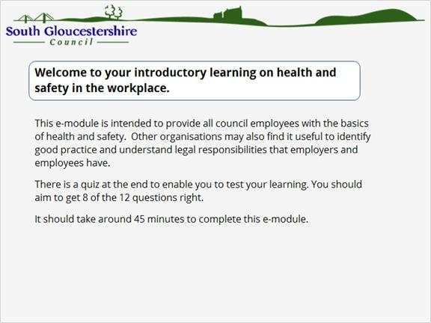

1.2 Overview
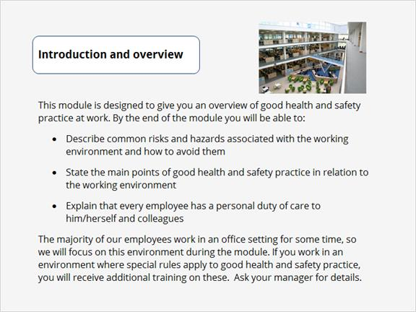

1.3 Common risks
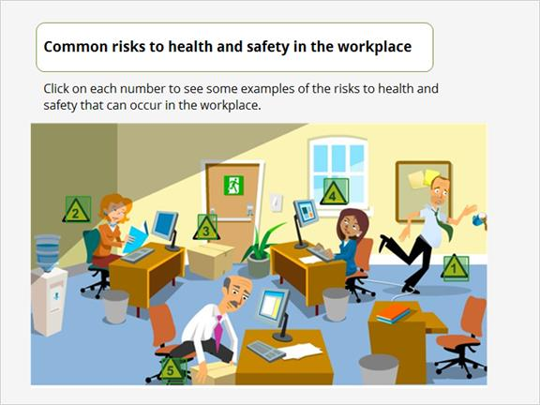
- Slips and falls
- Poor lighting
- Fire hazard
- Poor use of display equipment
- Manual handling

1.4 Meet the characters
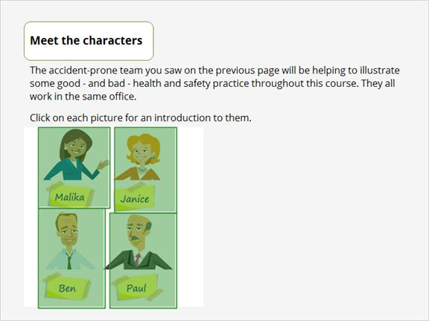
Malika has come into the office on a work experience placement. She's clever, well-qualified and ambitious, but not always very practical and some of the other team would say she lacks common sense.

Janice has just returned to work after taking a few years out to have a family. Having small children around the house has given her an unexpected skill in anticipating how accidents can happen around the office. She makes the most accurate assessment of risks in the office.

Ben is the office manager. He's responsible for implementing good health and safety practice in the workplace, but he can't be there all the time, in his absence standards do slip.

Paul has worked in the office for 23 years. There isn't much he doesn't know about how the office works, and he's rather cynical about change. He knows the law and health and safety good practice well, but still makes poor health and safety decisions at times.

1.5 What the terms mean
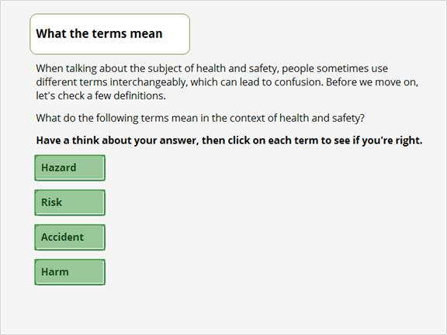
A hazard is something that has the potential to cause harm. For example:
- A strong cleaning agent may pose a potential danger to those people using it, perhaps if they get it on their skin.
- A trailing computer cable poses an avoidable trip hazard.

A risk is the chance that someone will be harmed by a hazard. For example:
- A person working with a hazardous substance runs a risk of injury when using it. However, following usage instructions reduces this risk to a minimum.
- If a trailing computer cable (i.e. a trip hazard) is not tidied away, there is a risk that someone could trip over it. Trips are the most common risk in the workplace.

An accident is an occurrence that is unplanned and undesirable. For example:
- A person working with a hazardous substance spills it.
- Someone trips over a trailing computer cable.

An accident does not necessarily lead to injury.
Harm is the impact of a work hazard. Harm can be sustained by objects in the form of damage or by persons in the form of injury. Harm is a common consequence of an accident. For example:
- A person working with a hazardous substance spills it on unprotected skin and sustains a burn.
- Someone spills coffee over a computer keyboard, rendering it unusable.
- Someone trips over a trailing computer cable and breaks a wrist.

2. Health and Safety Law and Policy

2.1 Who is legally responsible for health and safety at work?
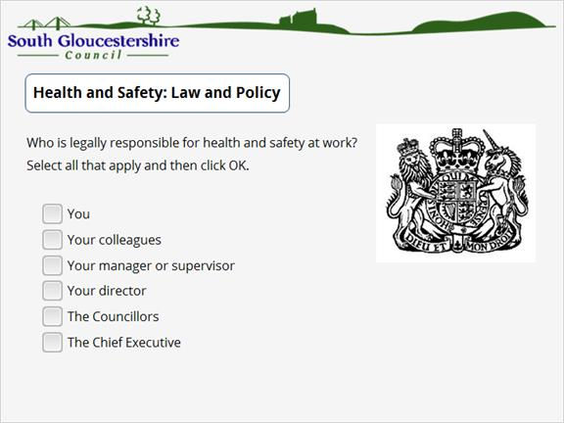
Correct | Choice
X | You
X | Your colleagues
X | Your manager or supervisor
X | Your director
X | The Councillors
X | The Chief Executive
Feedback:
The Act also applies to the self-employed, manufacturers and suppliers.

2.2 Health and safety policy
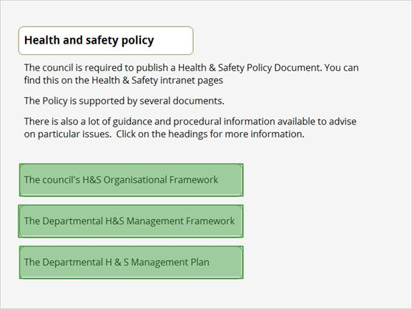
Organisational framework - this describes how the policy is put into practice and who has particular responsibilities.

Management framework - this describes the arrangements that departments put into place.

Management plan - this states the department's priorities and particular aims for the year.

2.3 Legal requirements
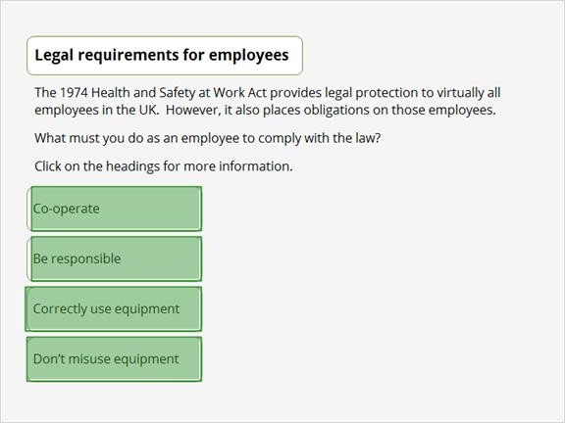
Co-operate
You must co-operate to enable your employer to comply with the law. This should include following procedures that are provided and reporting any problems related to the procedures, or any incidents, accidents etc.

Be responsible
You have a responsibility to take reasonable care for your own health and safety, and that of others who may be affected by your actions, or by your lack of action.

Correctly use equipment
You should correctly use work items, such as personal protective equipment, in accordance with the training or instruction that you have been given by your employer.

Don't misuse equipment
You should never interfere with or misuse anything that your employer has provided for health and safety purposes.

2.4 Legal responsibilities
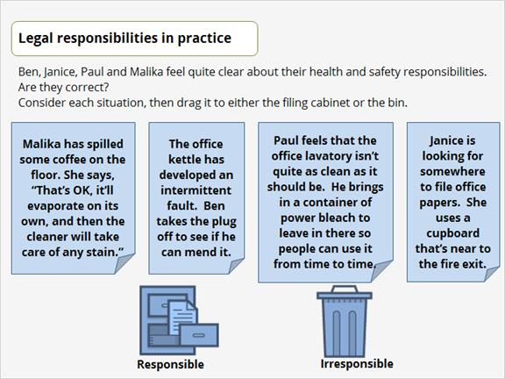
Correct answer:
Responsible:
Janice is looking for somewhere to file office papers. She uses a cupboard that’s near to the fire exit. Provided the cupboard next to the fire exit is not obstructing the exit in any way, it’s fine for Janice to use it.

Irresponsible:
Malika has spilled some coffee on the floor. She says, “That’s OK, it’ll evaporate on its own, and then the cleaner will take care of any stain.” Malika should never leave spilled fluid on the floor, as it is a slip hazard for her and her colleagues. Slip hazards are the biggest cause of health and safety related injury according to the HSE.
The office kettle has developed an intermittent fault. Ben takes the plug off to see if he can mend it. Ben should not interfere with any electrical appliance in the office. Nowadays all electrical appliances are sold with a sealed plug, so Ben should not in any event have removed it.
Paul feels that the office lavatory isn’t quite as clean as it should be. He brings in a container of power bleach to leave in there so people can use it from time to time. Paul has brought in a hazardous substance that needs special handling, it presents a danger to anyone who uses it.

3. Using a Workstation

3.1 Sitting at a desk and using a computer or other display screen equipment (DSE) is just part of everyday life for many employees. However, if you habitually use this kind of equipment for at least two hours a day, you need to make sure that it is used in a way that reduces risk. Safe use of a workstation depends on what the workstation is like and how it is used. What does this obligation require employers to do?
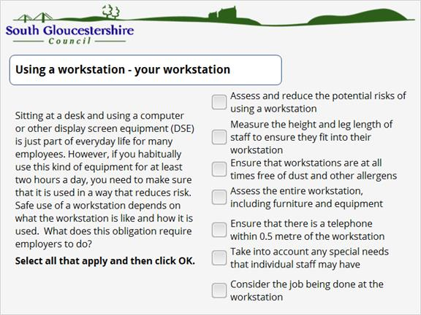

Correct | Choice
X | Assess and reduce the potential risks of using a workstation
 | Measure the height and leg length of staff to ensure they fit into their workstation
 | Ensure that workstations are at all times free of dust and other allergens
X | Assess the entire workstation, including furniture and equipment
 | Ensure that there is a telephone within 0.5 metre of the workstation
X | Take into account any special needs that individual staff may have
X | Consider the job being done at the workstation

3.2 You & your workstation
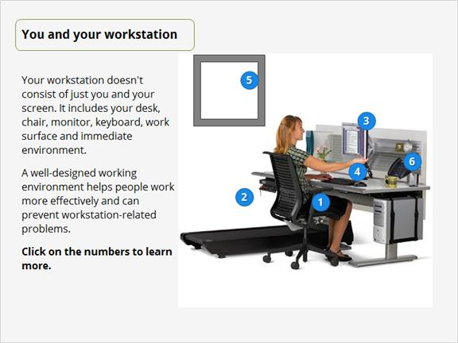
- You are the most important item in your office. When you sit down at your workstation, take a few moments to make sure you are comfortable with the lighting, temperature and noise levels of your area. Remember to look away from your desk from time to time to rest your eyes, and take plenty of breaks away from your workstation. Frequent short breaks are better than infrequent long breaks.
- The height of your chair, its arm rests and back should all be adjustable. The chair should have five feet and castors to ensure stability. You must have enough space to allow your feet to move around freely. The chair should be checked regularly and repaired or replaced immediately if a fault is detected.
- The angle and height of your monitor should be adjustable. It should tilt and swivel so you can minimise head and neck movement by maintaining a comfortable position. Your screen should be free of flicker and glare and you should be able to adjust its brightness, colour and contrast.
- The keyboard should tilt as required, be of a matte finish and have clear characters that can be easily read. You should also have enough space on your desk to have the keyboard in the position that suits you best.
- Whenever possible, workstations should be positioned with monitor screens at right angles to sources of natural light. Unshielded bright lights or bright lights in the field of vision can lead to visual fatigue. To minimise these problems consider shielding, replacing or repositioning office light sources.
- Organise your work surface to maximise your workspace. Position working documents at a height, visual plane and viewing distance similar to those of the screen. Bring all frequently used items within easy reach to avoid twisting and stretching. Anything that creates awkward reaches or angles in the body will put you under stress.

3.3 Posture
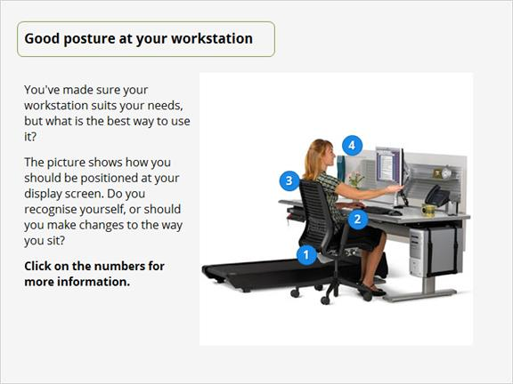
- The chair is positioned so that there is no pressure on the back of the legs. Forearms and thighs are level with the floor or slightly sloping away from the body.
- Your arms should be level with the surface on which the keyboard sits, keeping your wrists straight.
- You should sit up straight and maintain good posture. Your chair should be adjusted to help you maintain the natural curve in your lower back. Use a copy holder if you often need to refer to documents while you work.
- The top of the monitor screen should be slightly below eye level and positioned at arm’s length. The screen should be square to your line of sight as you sit in the correct position.

3.4 Pop quiz!
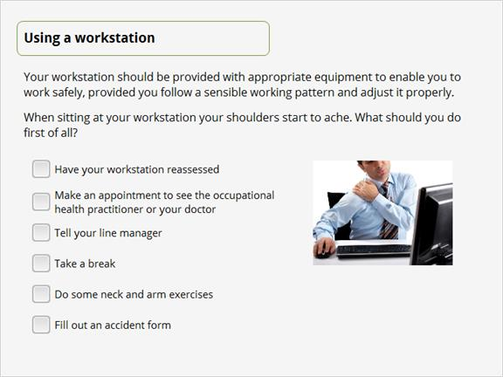

Correct | Choice
 | Have your workstation reassessed
 | Make an appointment to see the occupational health practitioner or your doctor
 | Tell your line manager
X | Take a break
 | Do some neck and arm exercises
 | Fill out an accident form

3.5 Top tips
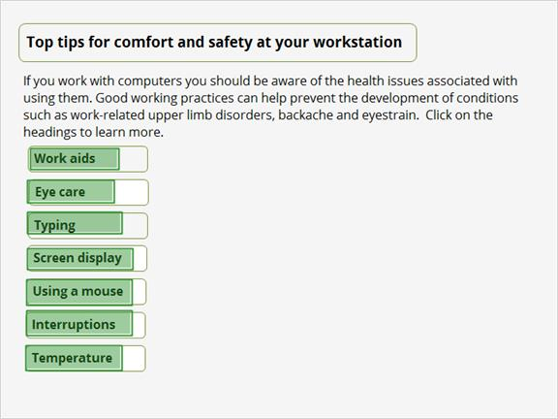
Work aids - you can use work aids such as footrests and monitor arms to help maintain a comfortable position as you work. Footrests can help prevent slouching and are useful when people are unable to rest their feet flat on the floor. A monitor arm allows you to adjust your screen in much the same way as an angle poise lamp. It helps reduce neck and head movement as you can place your work at eye level. It's also a useful way to free up space on your desk.

Typing - to avoid discomfort when typing, you should:
- Adjust your keyboard to a comfortable position
- Keep your wrists straight and don't overstretch your fingers
- Rest your hands and wrists when not typing
- Don't be tempted to hammer the keys - tap lightly

Screen display - to prevent leaning forward or hunching to see small items or read small text, increase the size of your screen display and/or font size to a suitable setting.

Mouse - to avoid discomfort when using a mouse, you should:
- Position the mouse so that it's in easy reach
- Keep your wrist straight and don't overstretch your arm
- Support your arm on the desk
- Avoid gripping the mouse too tightly and press lightly on the buttons.
- Consider an alternative mouse, such as a trackball or vertical mouse.

Interruptions - remember to look away from your desk from time to time to rest your eyes, and take plenty of breaks away from your workstation. Frequent short breaks are better than infrequent long breaks.

Temperature - ensure that the ambient room temperature is comfortable. You shouldn't feel too hot or too cold.

Eye care - long spells of concentration on work can lead to tired eyes and discomfort.
Tips to help ease eye discomfort:
- Make sure you are in a comfortable position and have your work documents in a good light
- Take regular breaks from the screen
- Remember to blink regularly to prevent dry eyes

4. Accidents and risk assessment

4.1 Accidents waiting
Ben, Malika, Janice and Paul are having a rather accident-prone day in the office. How many potential accidents can you spot in this picture?

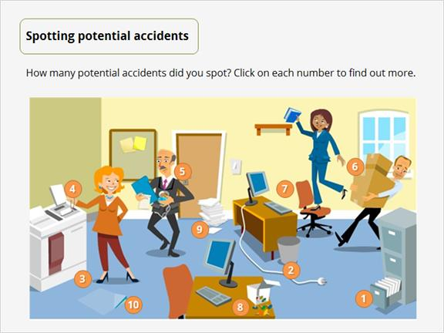
- The bottom drawer of this filing cabinet presents a trip hazard to anyone near it. Even if the trip is avoided, a nasty cut or bruise could still result.
- A trailing computer cable or electrical lead is a trip hazard.
- Janice is wearing very high heels, which could cause her to trip – especially as the office carpet is very worn in places.
- Janice’s dangly bracelet could become trapped in the document copier she’s using.
- Paul’s trying to carry far too many things at once – especially as one of those things is a hot drink.
- Not only is Ben carrying a box that’s too heavy for him, it’s too big for him to see that his way forward is clear.
- Malika is taking a huge risk by standing on this chair. Not only is it a swivel chair – it’s on castors!
- This box of drawing pins has been opened to attach a notice to the office noticeboard, but the unused pins have not been cleared away. There’s a risk of injury from those left on the desk or from any that might have fallen onto the floor.
- Paper, files and other paraphernalia should never be stacked on the floor. They present a slip and trip hazard.
- The office carpet tiles need replacing urgently as they present a serious trip hazard.

4.3 Accident reporting
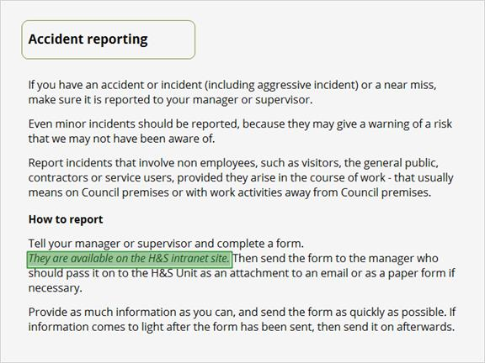

4.4 Accidents in the council
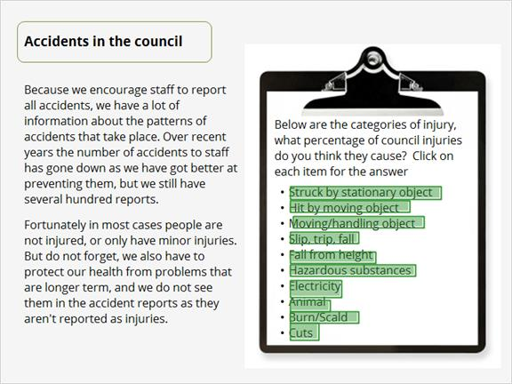
Cause of injury | % of council injuries caused by it
Stationary object | 11%
Hit by moving object | 22%, this is the second most common cause of injury at the council
Moving/handling object | 13%
Slip, trip, fall | 29%, the largest cause of injuries at the council
Fall from height | 2%
Hazardous substances | 1%
Electricity | 3%
Animal | 2%
Burn | 9%
Cuts | 10%

4.5 Risk assessments - purpose
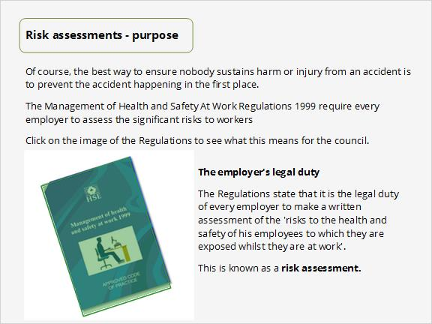

4.6 Risk assessments
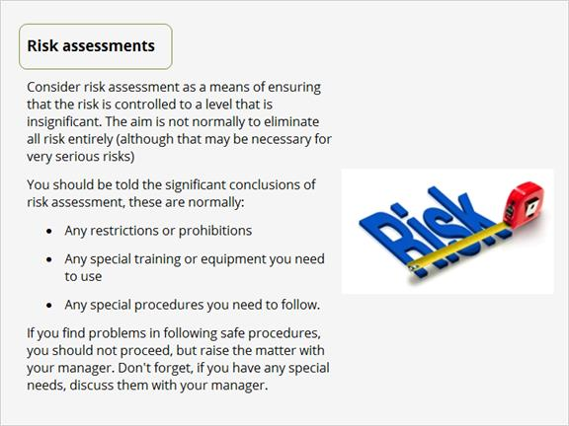

4.7 First aid
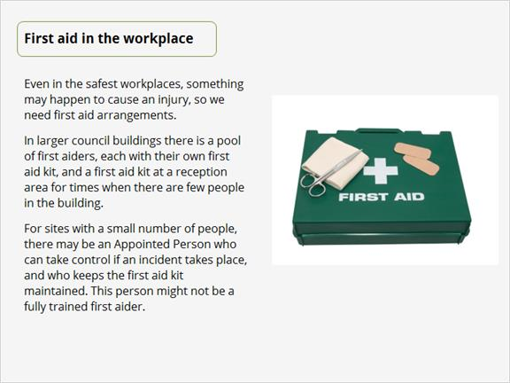

5. Dealing with particular risks

5.1 Equipment management
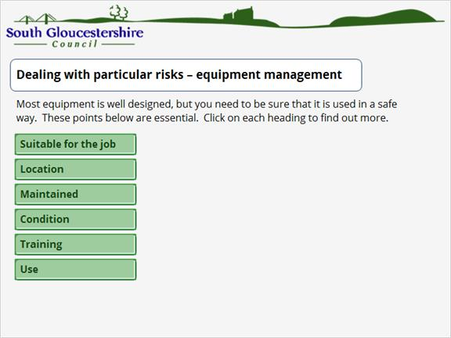
Risk | Explanation
Suitable for the job | Use equipment for the job it is intended for. Do not improvise.
Location | Some equipment is more dangerous in some conditions, for example, using electrical equipment in wet conditions.
Maintained | Make sure that the equipment’s maintenance schedule is follow if one exists.
Condition | Visually examine equipment before you use it and don’t use equipment that is damaged or has parts missing.
Training | Some equipment must only be used by people who have been specifically trained in its use.
Use | Follow the instructions!

Manual handling
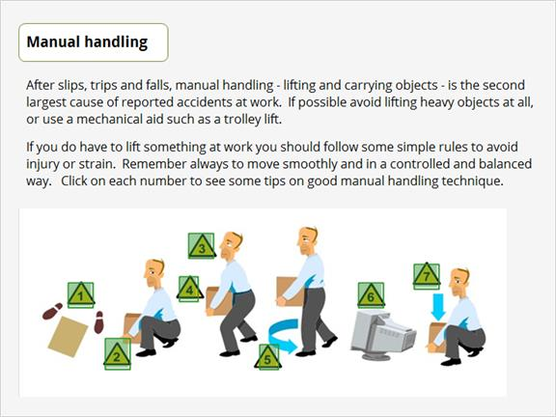
- Make a firm base with your feet, keeping them about shoulder width apart.
- Lift with the legs, bending the knees rather than the back.
- Keep the chin held in and raised as this helps keep the back straight.
- Ensure the load is as close to the body as possible.
- Do not twist the back but change direction by moving the feet.
- If the object is especially heavy or bulky, wait to get some help.
- Remember to take as much care when lowering items as when you lift them.

5.3 Hazardous substances
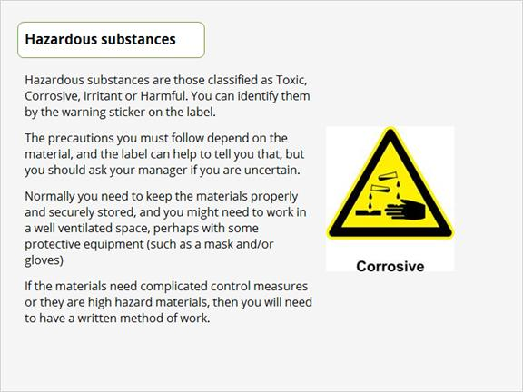

5.4 Common substances
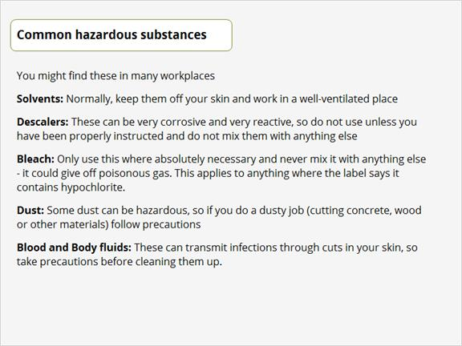

5.5 Working environment
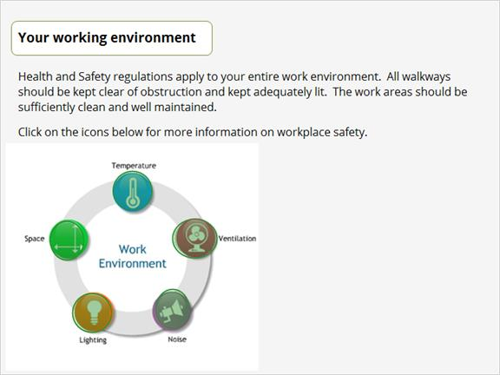
Temperature
Temperature inside buildings should provide reasonable comfort without the need to wear special clothing. Factors such as the environment around the workplace, the type of work being carried out and personal preferences make it difficult to specify a temperature that will suit everyone. However, 16 degrees Celsius is recommended as the minimum temperature for offices.

Ventilation
Workplaces must be adequately ventilated.
Ventilation should draw fresh, clean air in and remove warm, humid air.
Windows and doors may provide sufficient ventilation - if not, mechanical ventilation systems should be provided and maintained.

Noise
Exposure to loud noise over a prolonged period can cause hearing damage.
This does not normally affect people working in an office environment but you need to be aware of the risks and protected in certain situations, such as during maintenance or building work.

Lighting
All work areas must have suitable lighting to enable you to carry out work and move about safely. In addition, light fittings should not create any hazards.
If necessary, additional lighting should be provided at workstations and walkways.
Emergency lighting should be installed in areas where sudden loss of light would present serious risk - it should be automatic and powered by an independent source.

Space
Work areas should have enough room so that you can move about easily and access your personal work area without difficulty. A minimum of 11 cubic metres should be provided for each person permanently occupying a workplace.

6. Fire Safety

6.1 Problems
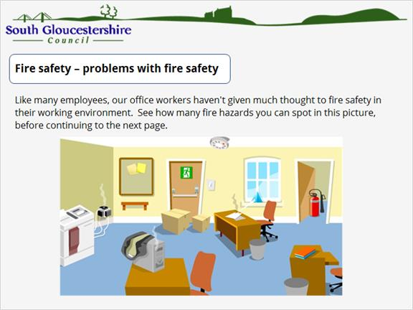

6.2 Spotting problems
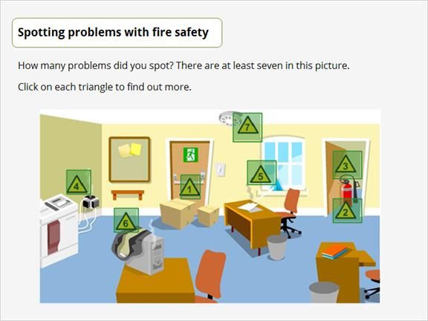
- The fire exit is partially blocked, which could slow down people escaping from a fire. Fire exits should always be entirely free from obstruction.
- The fire extinguisher is not on the wall bracket. In the event of a fire, someone needing to use the extinguisher may not be able to find it.
- This is an internal fire door, which is designed to close itself after use as it acts as a block to the spread of fire. Propping it open defeats the object.
- Overloaded sockets are very common causes of electrical fires. A good general rule is one plug to a socket. If you need more sockets, they should be professionally installed.
- The glass paperweight is focusing the sun’s rays onto the paper beneath. Eventually the papers will ignite.
- The jacket on top of this computer is blocking the air intake vents. This will cause the computer to overheat, which could cause a fire.
- This smoke alarm appears to be damaged. Smoke alarms are one of the very first alerts to the existence of fire, so if one is faulty precious seconds could be lost in the event of a fast spreading fire.

6.3 Fire response
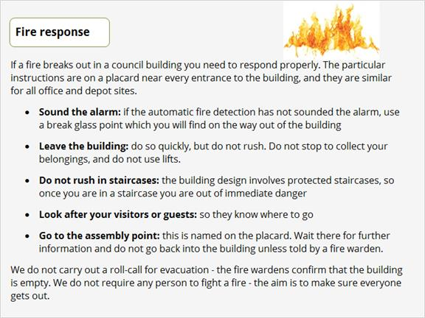

6.4 Prevention and preparation
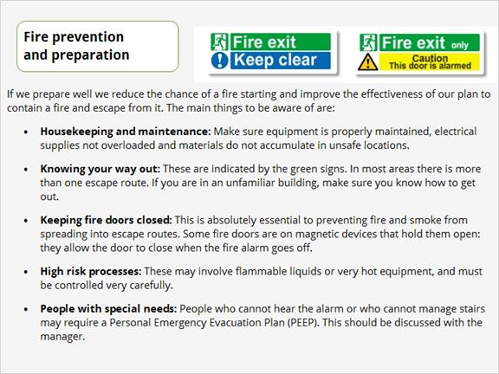

Which of the following should you do if you discover a fire?
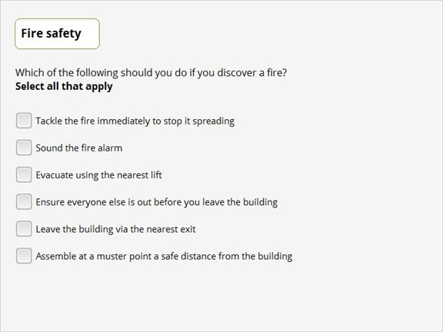

Correct | Choice
 | Tackle the fire immediately to stop it spreading
X | Sound the fire alarm
 | Evacuate using the nearest lift
 | Ensure everyone else is out before you leave the building
X | Leave the building via the nearest exit
X | Assemble at a muster point a safe distance from the building

The correct answer is that on discovering a fire, you should:

Sound the fire alarm, Leave the building via the nearest exit and Assemble at a muster point a safe distance from the building.

7. Stress in the workplace

7.1 Stress and pressure
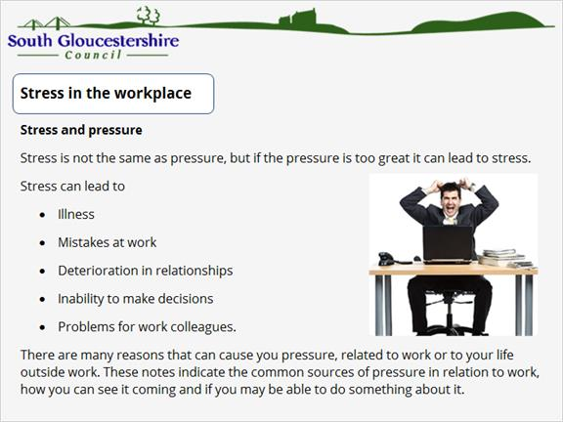

7.2 Causes of stress
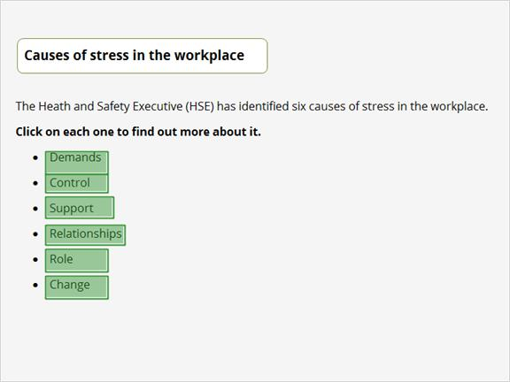
Demands
The demands of workload, work patterns and the work environment can exceed our ability to cope.

Control
We all need to have some say in the how, the when and the way we do our work.

Support
None of us can work in total isolation. We need encouragement, sponsorship and resources from our organisation, line management and colleagues.

Relationships
As with any other part of life, relationships at work can sometimes be difficult. We need to promote positive working to avoid conflict and dealing with unacceptable behaviour.

Role
Feeling unclear about what is expected of us at work can leave us feeling very unsure of ourselves. We should all understand our roles within the organisation and the organisation should ensure that we do not have conflicting roles.

Change
Any organisational change, large or small, should involve us. It should be well-managed and communicated to all involved. Change that happens without our involvement tends to make us feel excluded from an organisation in which we are likely to have a considerable stake as employees.

7.3 Recognising Stress
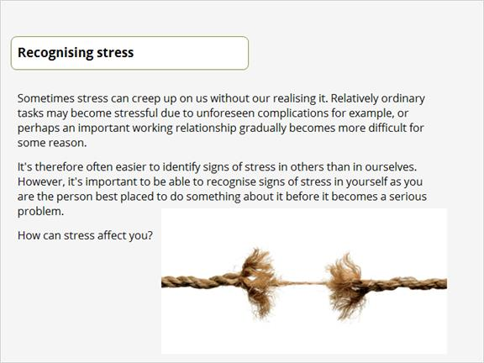

7.4 Signs of stress
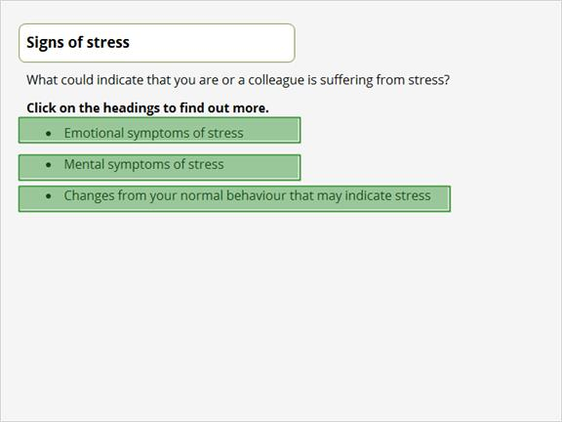
Emotional symptoms of stress
- Feeling negative or depressed
- Disappointment with yourself
- Reacting to things more emotionally - more tearful or sensitive or aggressive
- Withdrawing, feeling lonely or isolated
- Loss of confidence, commitment and motivation
- Unexplained mood swings, even if these don't affect your behaviour

Mental symptoms of stress
- Feeling confused and indecisive
- Inability to concentrate
- Poor memory

Changes from your normal behaviour that may indicate stress
- Changed eating habits
- Increased smoking, drinking or drug-taking 'to cope'
- Mood swings that affect your behaviour
- Changes in sleep patterns
- Twitchy, nervous responses to others
- Changes in work attendance such as arriving later or taking more time off

Which of the following will help him cope with the situation?
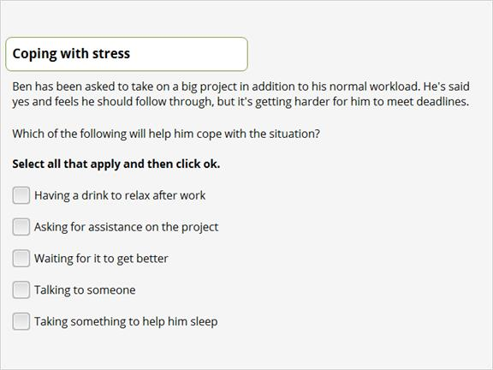
Correct | Choice
 | Having a drink to relax after work
X | Asking for assistance on the project
 | Waiting for it to get better
X | Talking to someone
 | Taking something to help him sleep

7.6 Who to approach for help
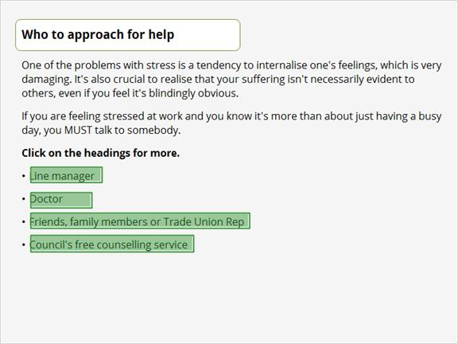
Line Manager
You may feel that if you approach your manager with problems about stress you will be admitting failure. You're not. Very often your manager is best placed to help you to take practical measures to address the sources of pressure.
Of course, if you do not feel that you can discuss the matter with your manager, you may need to speak with someone else: the council's human resources (HR) service may be an appropriate source of help.

Doctor
If you do experience symptoms that appear to be due to stress, be careful not to assume that stress is in fact the cause. What you're feeling may be due to some other health problem, so it's important to get yourself checked over by your doctor or other health professional.

Friends
You may find it helpful to talk in the first instance to someone who is in your corner but is not connected with work. This can help you sort out your thoughts and see how to move forward more clearly, so that you feel more confident about approaching a work colleague to discuss the problem. If you are in a trade union, you may find it useful to speak with your representative.

Counselling
The confidential counselling service is operated by an independent provider (Interchange - telephone 0117 983 1465) and any employee can contact it directly for help. Nothing will be disclosed to any other person without your agreement.

8. Lone Working

8.1 Lone Working
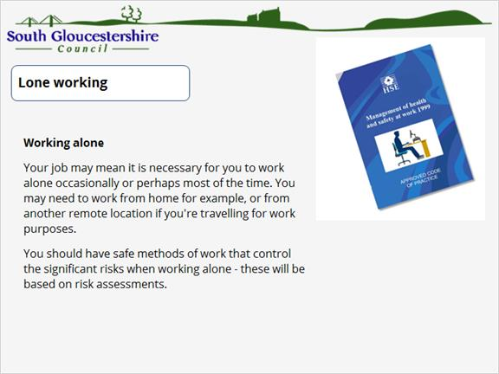

8.2 Control measures
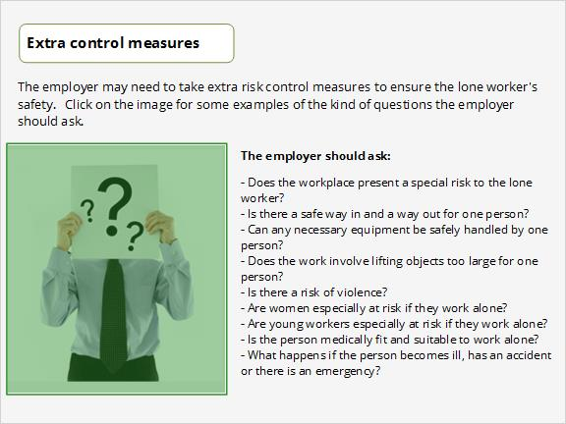

8.3 Working at home
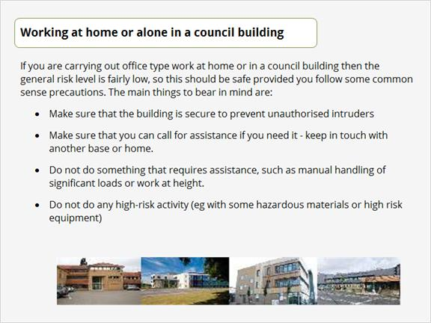

8.4 Visiting alone
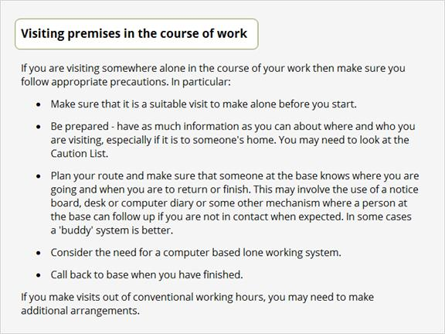

9. Resources and useful links

9.1 H&S on the intranet
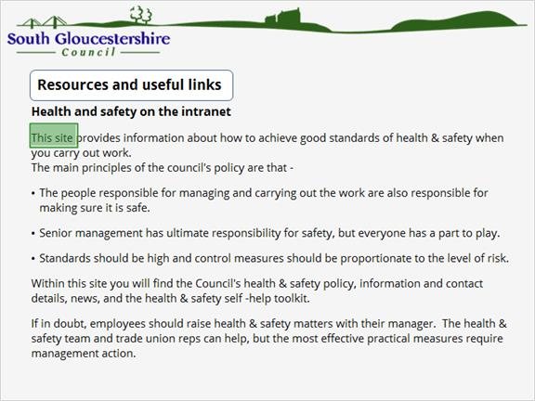
Go to the A-Z on the intranet, and select to find a link to the Health and Safety intranet site or click on the below link:
http://intranet/content/CEandCR/Sections/HealthSafety/new/Home%20Page/Home%20Page.htm

9.2 Further information
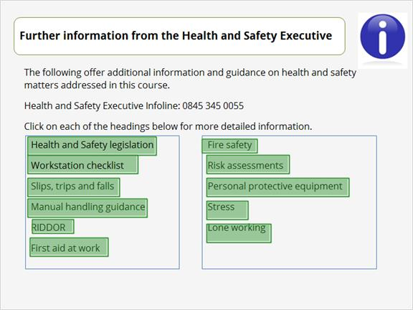
You will information on all of these topics at www.hse.gov.uk.

10. Assessment
There now follows an assessment on what you have learned in your Introduction to Health and Safety course. The assessment contains 12 questions.
Good luck!

Question 1. What is the commonest risk to health and safety in the workplace?

- Stress
- Poor use of display screen equipment
- Slips, trips and falls
- Fire
- Hazardous substances
- Electricity

Question 2. “Something has the potential to cause harm”. Which of the following does this best describe?

- A tidied computer cable
- Accident
- Risk
- Hazard
- Mistake
- An injured person

Question 3. For which of the following is the employee responsible in the workplace?

- Don’t misuse equipment
- Find out if the employer has a health and safety policy
- Co-operate
- Inform the employer of any specific health and safety responsibilities you may have
- Be responsible
- Correctly use equipment.

Question 4. When assessing your work station for good health and safety practice, which of the following should you consider?

- Your posture
- Your chair
- Your monitor
- Your keyboard
- Lighting conditions
- Your work surface

Question 5. Which of the following is the best description of a formal risk assessment?

- A written assessment by the employer of the risks to the health and safety of his employees to which they are exposed whilst they are at work
- A record or report of the recurrence of an accident due to a previously identified hazard
- An undesirable or unfortunate happening that occurs unintentionally and usually results in harm, injury, damage or loss
- A record or report of the recurrence of an accident due to a previously identified risk
- An assessment of how the Management of Health and Safety at Work Regulations 1999 applies to the relevant workplace
- A written assessment by the employee of the risks to the health and safety to which they are exposed whilst they are at work.

Question 6. For the purposes of first aid, what are the specific responsibilities of an appointed person?

- The person who takes charge when someone is injured or falls ill
- The person who looks after the first aid equipment
- The person who resuscitates anyone who is injured or ill
- A person who has undergone a training course in administering first aid at work
- A person who holds a current first aid at work certificate
- A person who writes and displays the first aid information

Question 7. Which of the following are good practice in manual handling?

- Make a firm base with your feet, keeping them about shoulder width apart
- Lift with the legs, bending the back
- Keep the chin pushed out and down to help keep the back straight
- Ensure the load is as close to the body as possible
- Do not twist the back but change direction by moving the feet
- Take as much care when lowering items as when you lift them

Question 8. If you discover a fire, what actions should you take and in what order? Put the items into the correct order.

- Leave the building by the nearest exist without using the lifts
- Ensure your own safety
- Assemble with your colleagues at a designated point away from the building
- Shout “Fire, Fire!” at the top of your voice
- Sound the nearest fire alarm

Question 9. Which of the following aspects of health and safety should be considered in the working environment?

- Lighting
- Noise
- Temperature
- Space
- Ventilation

Question 10. Which of the following has the Health and Safety Executive identified as a cause of stress in the workplace?

- Control
- Demands
- Support
- Role
- Change
- Relationships

Question 11. Which of the following are ideal ways to cope with stress?

- Taking sleeping pills to ensure a good night’s rest
- Telling a friend, family member or trusted colleague about the problem
- Having a drink or two after work to relax
- Consulting your doctor
- Advising your line manager
- Talking to an occupational health practitioner if one is available

Question 12. Your employer may need to take extra control measures to ensure your health and safety if you are working alone. Which of the following are questions that your employer should ask?

- Does the workplace present a special risk to the lone worker?
- Is there a risk of violence?
- Does the lone worker have enough to eat?
- Are men especially at risk if they work alone?
- Is the person medically fit and suitable to work alone?
- Is there a safe way in and a way out for one person?

